DESIGN & DEVELOPMENT OF .Journal

A
MAJOR PROJECT-I REPORT
Submitted in partial fulfillment of the requirements
for the degree of
BACHELOR OF TECHNOLOGY
in
COMPUTER SCIENCE & ENGINEERING
By
GROUP NO. 52
Aakash Shardul | 0187CS171002

Under the guidance of
Dr. Vasima khan
(Assistant Professor)

December-2020
Department of COMPUTER SCIENCE & ENGINEERING
Sagar Institute of Science & Technology (SISTec)
Bhopal (M.P.)
Approved by AICTE, New Delhi & Govt. of M.P.
Affiliated to Rajiv Gandhi Proudyogiki Vishwavidyalaya, Bhopal (M.P.)

Sagar Institute of Science & Technology (SISTec), Bhopal

Department of COMPUTER SCIENCE & ENGINEERING
Bhopal (M.P.)
Dec-2020

CERTIFICATE

I hereby certify that the work which is being presented in the B.Tech. Major Project-I Report entitled .Journal, in partial fulfillment of the requirements for the award of the degree of Bachelor of Technology in Computer Science & Engineering and submitted to the Department of Computer Science & Engineering, Sagar Institute of Science & Technology (SISTec), Bhopal (M.P.) is an authentic record of my own work carried out during the period from Jul-2020 to Dec-2020 under the supervision of Dr. Vasima Khan.
The content presented in this project has not been submitted by me for the award of any other degree elsewhere.

Signature

Aakash Shardul
0187CS171002

This is to certify that the above statement made by the candidate is correct to the best of my knowledge.
Date:

Project Guide

HOD

Principal

TABLE OF CONTENTS

TITLE |  |  | PAGE NO.
Abstract |  |  | 1
Acknowledgement |  |  | 2
List of tables |  |  | 3
List of figures |  |  | 4
List of abbreviations |  |  | 5
Chapter 1 | Introduction |  | 7
 | 1.2 | About Project
 | 1.3 | Project Objectives
Chapter 2 | Software & Hardware Requirements |  | 9
 | 2.2 Software Requirements |  | 10
 | 2.2.1 Python
 | 2.2.2 Django
 | 2.3 Hardware Requirements |  | 11
Chapter 3 | Problem Description |  | 12
 | 3.2 Existing Scenario
 | 3.3 Drawback
 | 3.4 Features of the proposed system
 | 3.5 Future advancements and upgrades
Chapter 4 | Software Requirements Specification |  | 14
 | 4.1 | Functional Requirements
 |  | 4.1.1 LOGIN
 |  | 4.1.2 SET PROFILE
 |  | 4.1.3 DISPLAY
 | 4.2 | Non-Functional Requirements
 |  | 4.2.1 Scalability
Chapter 5 | Software Design |  | 16
 | 5.2 | Use Case Diagram
 | 5.3 | Table Structure
Chapter 6 | Output Screens |  | 24
Appendix-1: Glossary of Terms |  |  | 29
References |  |  | 32

ABSTRACT
The .Journal is a python-based web application developed to help people to search for any kind of news. Our platform allows a person to login and setup his profile and fill all his choices for the updated news.

In this project we use agile SDLC model it is a combination of iterative and incremental process models with focus on process adaptability and customer satisfaction by rapid delivery of working software product. Agile Methods break the product into small incremental builds.

The internet is filled with information and news, and keeping on top of all of it is next to impossible. Just think of all the different websites that are out there and the information they provide. Visiting every single one that you’re interested in can be an immense and time-consuming task. That’s where news aggregators come in. While not a new concept, news aggregators can save you the time and resources that would normally be needed to gather all this information into a digestible portion.
Staying on top of the news like this helps you to remain competitive. It helps you to know what the latest trends are and what your closest competitors are up to.

This project is done using Python for backend using Django framework for creating web application.

1
ACKNOWLEDGEMENT

It gives us immense pleasure to express our deepest sense of gratitude and sincere thanks to our highly respected and esteemed guide and our Project Coordinator Dr. Vasima Khan, Department of Computer Science and Engineering, SISTec Gandhi Nagar Bhopal, for their valuable guidance, encouragement and help for completing this work. Their useful suggestions for this whole work and co-operative behavior are sincerely acknowledged.

We would like to express our sincere thanks to Dr. Keshavendra Choudhary, Principal, SISTec, Gandhi Nagar, Bhopal for giving us an opportunity to undertake this project.

We also wish to express our gratitude to Prof. Ujjwal Nigam, Head, Department of Computer Science and Engineering, for his kind hearted support.

At the end, we would like to express our sincere thanks to all our friends and others who helped us directly or indirectly during this project work.

Name | Enrollment Number | Signature
Aakash Shardul | 0187CS171002

2

LIST OF TABLES

TABLE NO. | TITLE OF TABLE | PAGE NO.
5.3.1 | User Table
5.3.2 | Read News Table
5.3.2 | Politics News Table
5.3.4 | Sports News Table
5.3.5 | Entertainment News Table
5.3.6 | Business News Table

3

LIST OF FIGURES

FIG. NO. | TITLE | PAGE NO.
5.1 | Use Case Diagram
6.1 | Installing Our Tool
6.2 | Installation
6.3 | Executing Dope
6.4 | Testing sample error code
6.5 | Testing of error file
6.6 | List of Possible Solutions
6.7 | Selected Output

4

LIST OF ABBREVIATIONS
ACRONYMS | FULL FORMs
SQL | Structured Query Language
HTML | Hyper Text Markup Language
CSS | Cascading Style Sheets
UML | Unified Modeling Language
ERD | Entity Relationship Diagram
DB | Data Base

5

7

CHAPTER - 1
INTRODUCTION TO PROJECT

  - INTRODUCTION

A news aggregator provides and updates information from different sources in a systematized way. .Journal also provide update services, whereby a user is regularly updated with the latest news on a chosen topic.
A news aggregator is a combination of web crawlers and web applications. Both of these technologies have their implementation in Python.

  - ABOUT PROJECT

It is a web application which aggregates data (news articles) from multiple websites. Then presents the data in one location.
News aggregator service is a very important start of the day.
There are various publications and news sites online. They publish their content on multiple platforms. Now, when we open 10-20 news sites every day, we waste time to gain information.
A news aggregator makes this task easier. In a news aggregator, you can select the websites you want to follow. Then the news aggregator collects the articles for you. And, you are just a click away to get information from various websites.
- The proposed system “.Journal” allows a user to search for the latest information in a field.
- The proposed system fetches the data from multiple sources to collect the News.
- There is another functionality will be added for user that he can save News for future.

  - PROJECT OBJECTIVE

The Objective of .Journal is to provide a better place to the user where they can read latest news fetched from multiple websites in one location
- Reduced searching time.

- Increased reliability.

- Increased operational efficiency.

- Data security.

- To reduce manual Visit in each and every site

8

9
CHAPTER - 2
SOFTWARE & HARDWARE REQUIREMENTS

2.1 INTRODUCTION

To be used efficiently, all computer needs certain hardware component or other software resources to be present on a computer these perquisites are known as system requirements. Most software defines two sets of system requirements: minimum and recommended with increasing demand for higher processing power and resources in new version of software of system requirements to increase our time.

2.2 SOFTWARE REQUIREMENTS

Software is part of computer system that consist of data and computer instructions, in contrast to the physical hardware from which the system is built. In computer science and software engineering, computer software is all information processed by computer system, Program and data. Computer software include computer program library dependencies and related nonexecutable data such as online documentation or digital media in this project. We have used following software:

2.2.1 PYTHON

Python is one of those rare languages which can claim to be both simple and powerful. You will find yourself pleasantly surprised to see how easy it is to concentrate on the solution to the problem rather than the syntax and structure of the language you are programming.

2.2.2 DJANGO

Django is a high-level Python Web framework that encourages rapid development and clean, pragmatic design. Built by experienced developers, it takes care of much of the hassle of Web development, so you can focus on writing your app without needing to reinvent the wheel. It’s free and open source.

2.2.3 SCRAPY

Scrapy is a Python framework for large scale web scraping. It gives you all the tools you need to efficiently extract data from websites, process them as you want, and store them in your preferred and format. Even Big Gaint uses this framework to built the crawler

10
2.3 HARDWARE REQUIREMENTS

The most common set of requirements defined by any operating system or software application is the physical computer resources, also known as hardware or we can say hardware is the collection of all parts, which we can touch. The most common set of requirements defined by any operating system of software application is the physical computer resources also known as Hardware. Hardware requirements list often accompanied by a Hardware Compatibility List, especially case of operating systems. Hardware that is necessary for this project is:

Table 2.3 Hardware Requirements
Processor | Intel Core
Ram | 1 GB
Hard Disk | 4 GB

11

12
CHAPTER - 3
PROBLEM DESCRIPTION

3.1 INTRODUCTION

A news aggregator provides and updates information from different sources in a systematized way. .Journal also provide update services, whereby a user is regularly updated with the latest news on a chosen topic.
A news aggregator is a combination of web crawlers and web applications. Both of these technologies have their implementation in Python.

3.2 EXISTING SCENARIO

Mostly people search for news from every existing websites for being updated and so it gets very much time consuming to search for the news of a particular choice.

3.3 DRAWBACK

The existing system is not able to save the news neither it has functionality of sharing the news.

3.4 FEATURES OF THE PROPOSED SYSTEM

- Easy to use.
- Provides an interactive and user-friendly interface to users.
- Efficient, reliable, fast and accurate results are provided.
- Utilization of time and workspace.
- Upgrading the level of working and presentation.

3.5 FUTURE ADVANCEMENTS AND UPGRADES

Currently we are filtering latest News as per user’s interest and presents them. We are looking forward for a place where we can merge news reporters to add the news

- Chat bot help assist a person for being more user imteractive..
- And to check correctness of the news we can add machine so that we can detect about the how much reality a News contains.

13

5

14
CHAPTER - 4
SOFTWARE REQUIREMENT SPECIFICATION

4.1 FUNCTIONAL REQUIREMENTS

A Functional Requirement (FR) is a description of the service that the software must offer. It describes a software system or its component. A function is nothing but inputs to the
6
software system, its behavior, and outputs. It can be a calculation, data manipulation, business process, user interaction, or any other specific functionality which defines what function a system is likely to perform. Functional Requirements are also called Functional Specification.

4.2.1 LOGIN

people can register themselves and login to our portal.

4.2.2 SET PROFILE

Person can set his/her profile and update their Field of interests..

4.2.3 DISPLAY News

Displays the news post to the users.

4.3 NON-FUNCTIONAL REQUIREMENTS

NON-Functional Requirements (NFR) specifies the quality attribute of a software system. They judge the software system based on Responsiveness, Usability, Security, Portability and other non-functional standards that are critical to the success of the software system. Example of non-functional requirement, “how fast does the website load?” Failing to meet non-functional requirements can result in systems that fail to satisfy user needs.
Non-functional Requirements allows you to impose constraints or restrictions on the design of the system across the various agile backlogs.

4.3.1 SCALABILITY

The scope of our project worldwide. Anyone student across the globe can make a free user-id and login to our platform and any company can register on our platform as well.

15

16
CHAPTER - 5
SOFTWARE DESIGN

5.1 INTRODUCTION

Software design is a process to transform user requirements into some suitable form, which helps the programmer in software coding and implementation. For assessing user requirements, an SRS (Software Requirement Specification) document is created whereas for coding and implementation, there is a need of more specific and detailed requirements in software terms. The output of this process can directly be used into implementation in programming languages. Software design is the first step in SDLC (Software Design Life Cycle), which moves the concentration from problem domain to solution domain. It tries to specify how to fulfill the requirements mentioned in SRS.

5.2 USE CASE DIAGRAM
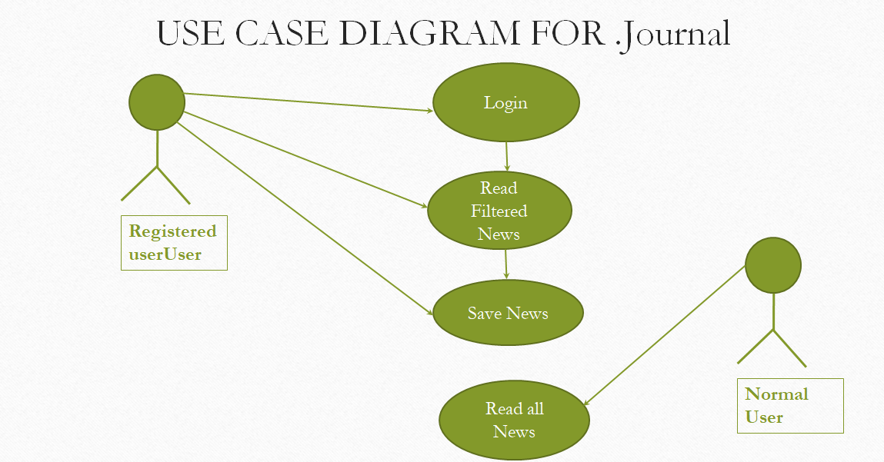
Figure 5.2 Use Case Diagram

17

5.3 TABLE STRUCTURE

Table structure transforms ER diagram into a table which is intersection of rows and columns. Here each column is a depicted form of an attribute and entity into table name.

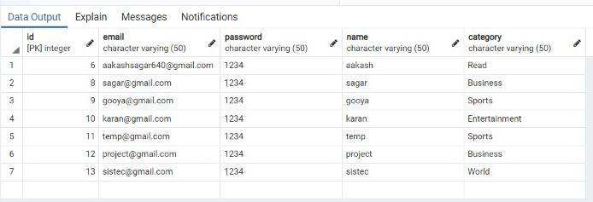

Figure 5.3.1: User Table

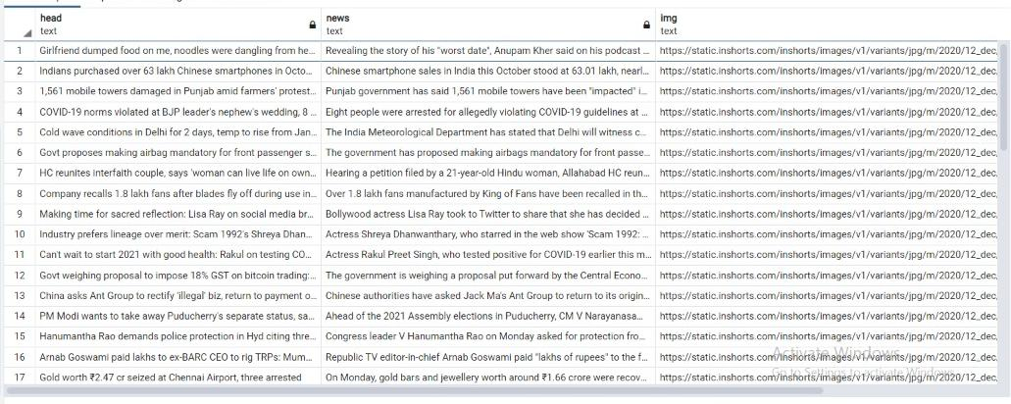
Figure 5.3.2: Read News Table

18
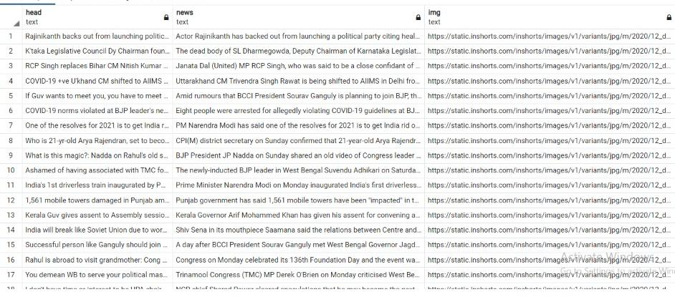
Figure 5.3.3: Politics News Table

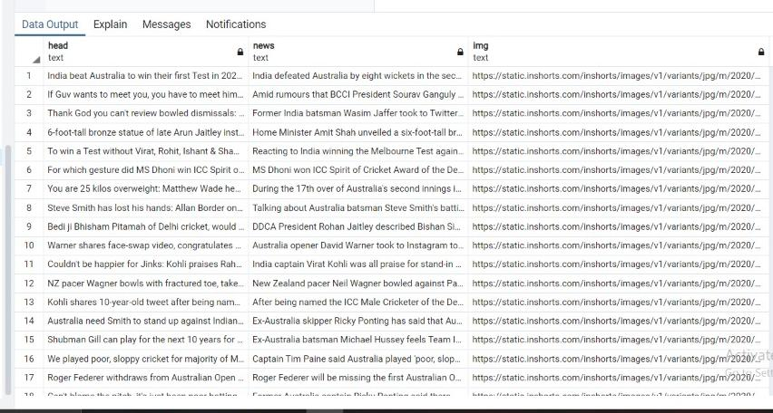

Figure 5.3.4: Sports News Table

19
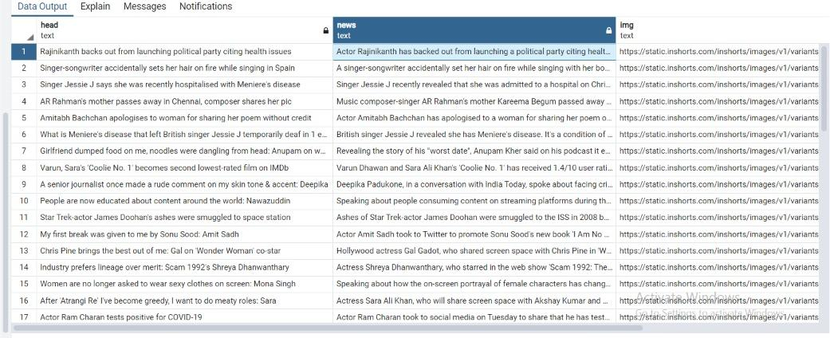

Figure 5.3.5: Entertainment News Table

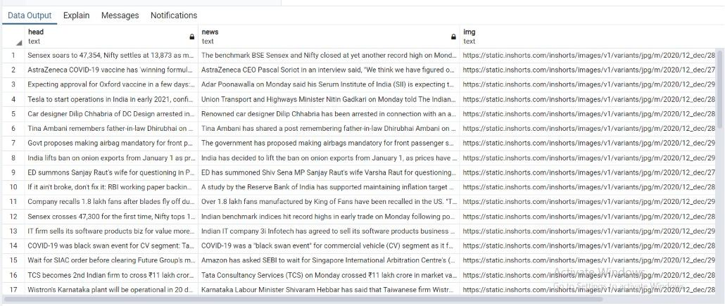

Figure 5.3.6: Business News Table

20

21

22
CHAPTER - 6
E-R DIAGRAM

6.1 INTRODUCTION

An entity–relationship model (or ER model) describes interrelated things of interest in a specific domain of knowledge. A basic ER model is composed of entity types (which classify the things of interest) and specifies relationships that can exist between entities (instances of those entity types).
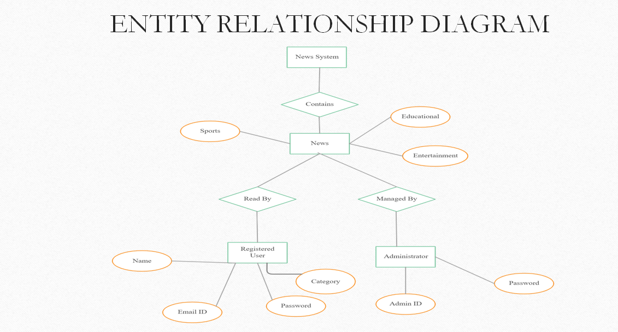

9

23

24
CHAPTER - 7
OUTPUT SCREEN

7.1 INTRODUCTION

An output screen is the view how the web application will be display.

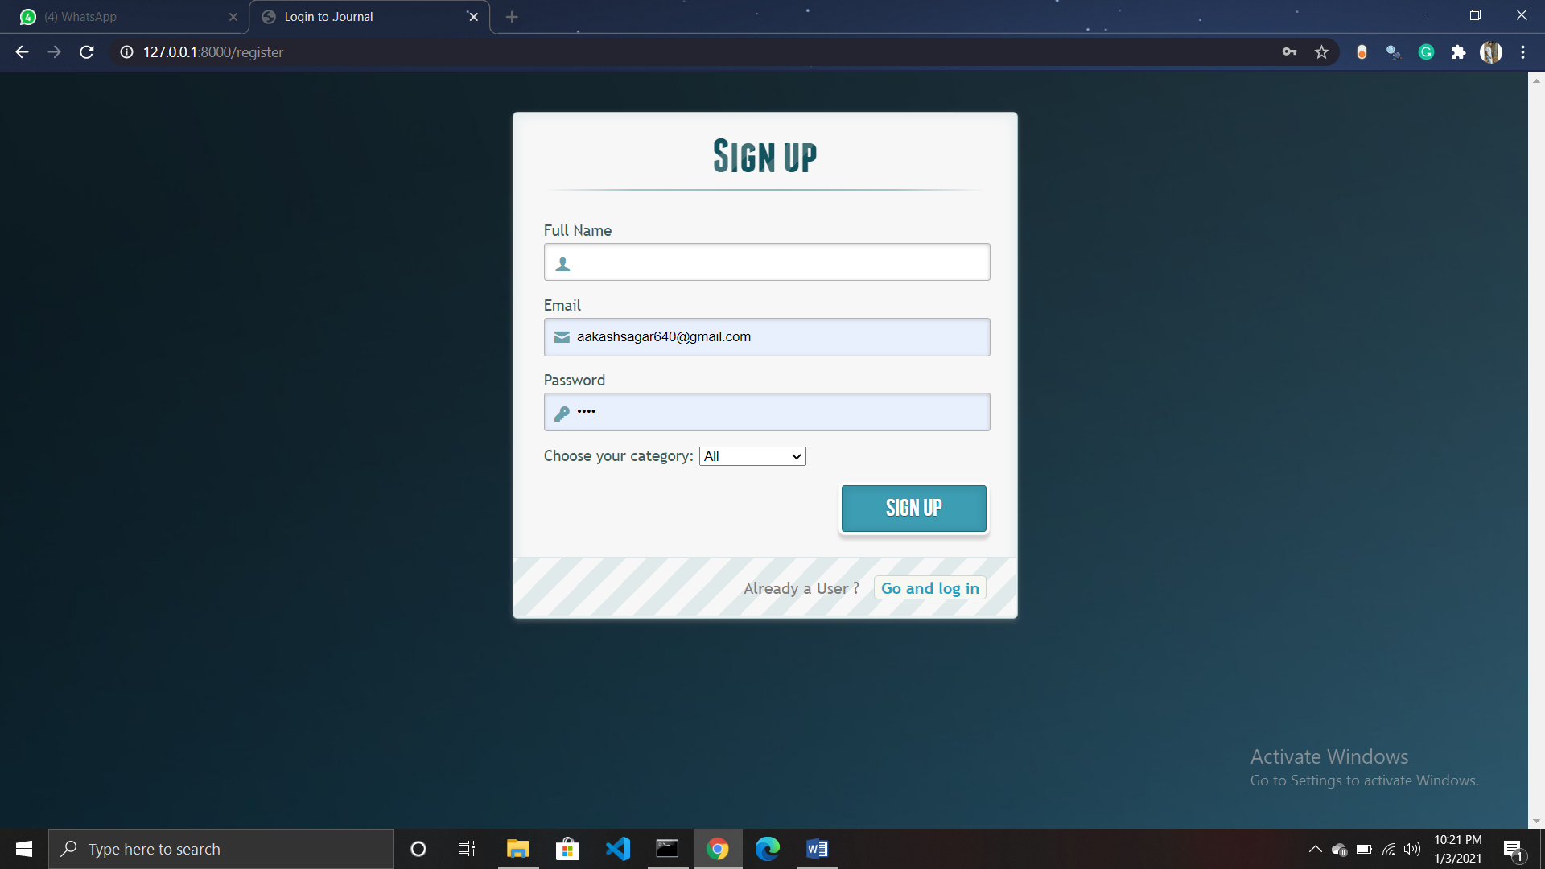
Figure 7.1

25

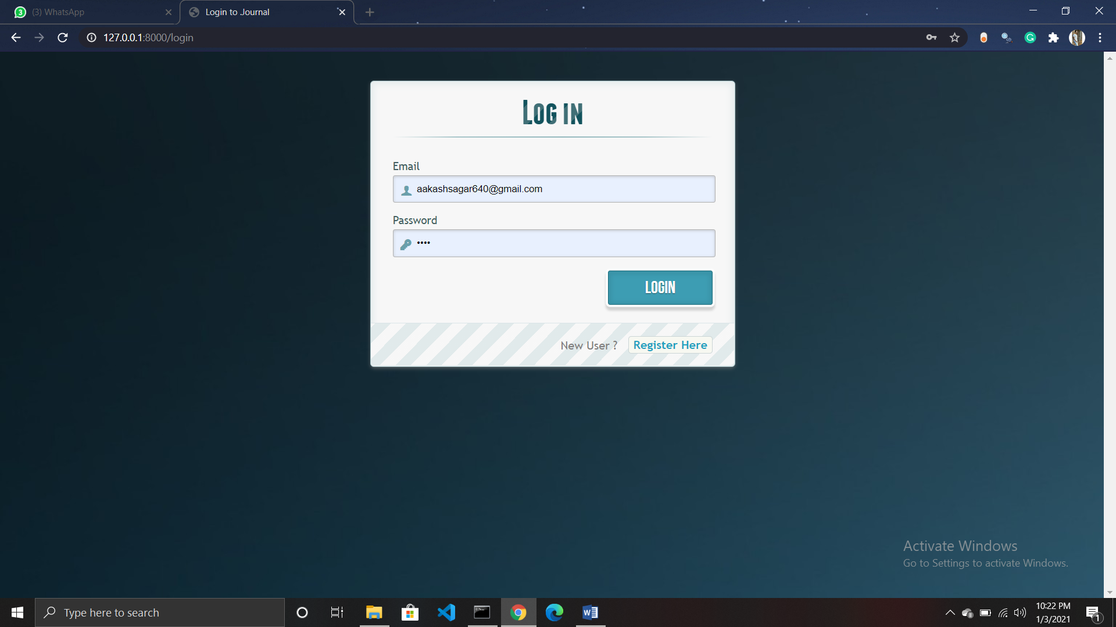
Figure 7.2

26

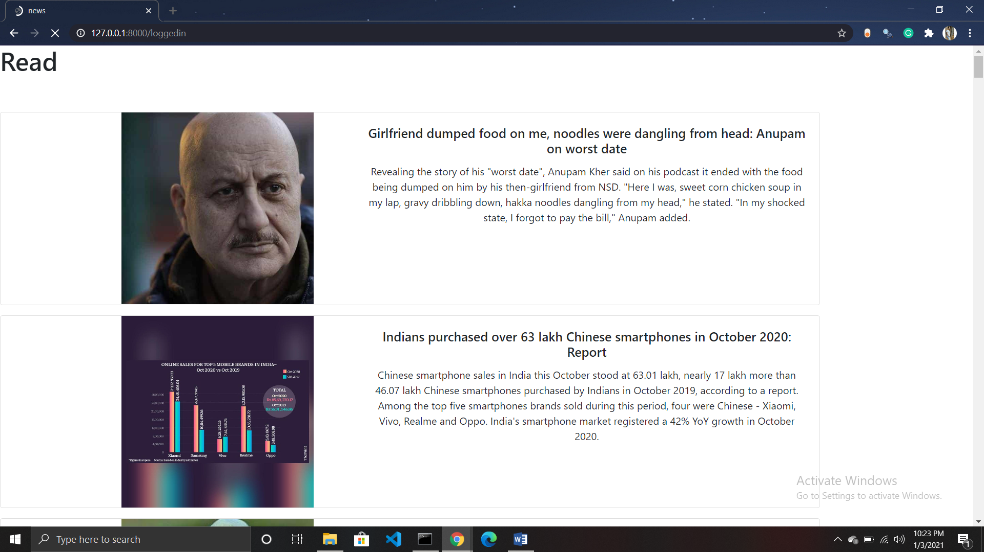
Figure 7.3

27

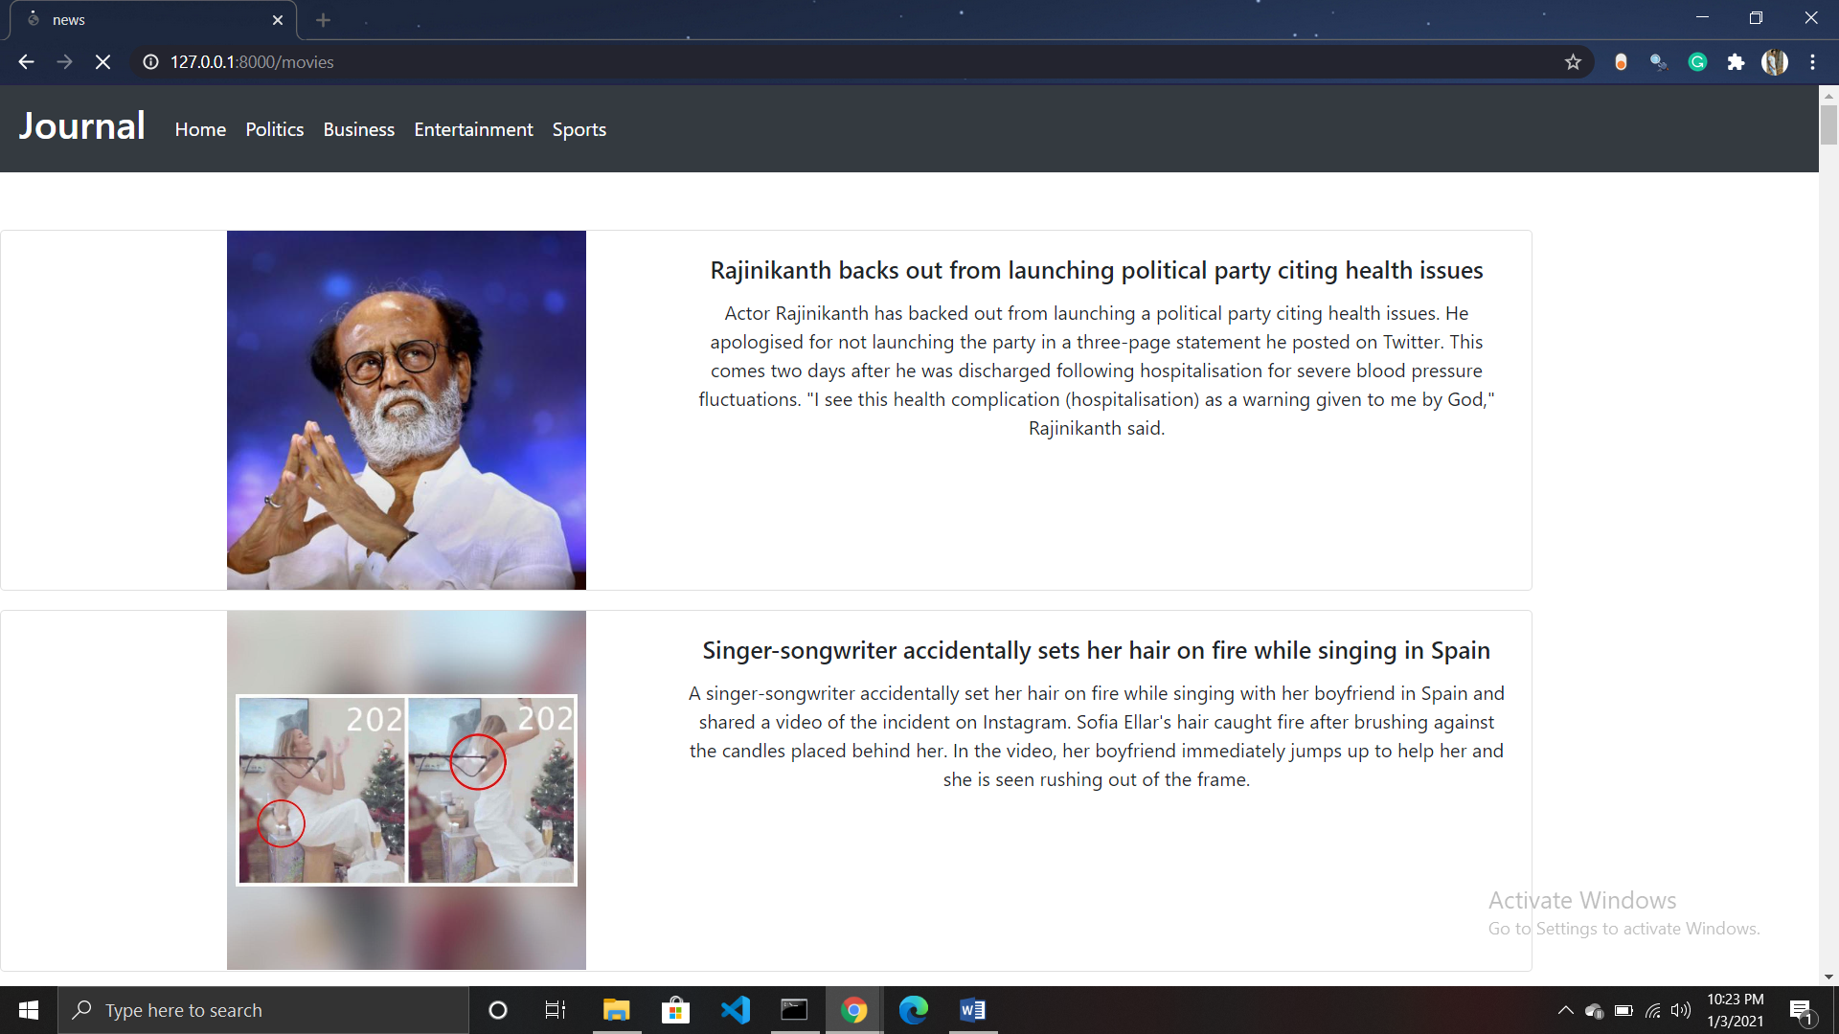
Figure 7.4 Output

28

29
APPENDIX-1 GLOSSARY OF TERMS

D

Django With Django, you can take Web applications from concept to launch in a matter of hours. Django takes care of much of the hassle of Web development, so you can focus on writing your app without needing to reinvent the wheel. It’s free and open source.

Django was designed to help developers take applications from concept to completion as quickly as possible.

Django includes dozens of extras you can use to handle common Web development tasks. Django takes care of user authentication, content administration, site maps, RSS feeds, and many more tasks — right out of the box.
H

Html : HTML is the standard markup language for creating Web pages.

- HTML stands for Hyper Text Markup Language.
- HTML describes the structure of a Web page.

- HTML consists of a series of elements.
- HTML elements tell the browser how to display the content.

- HTML elements are represented by tags.

- HTML tags label pieces of content such as "heading", "paragraph", "table", and so on.

- Browsers do not display the HTML tags, but use them to render the content of the page.

P

Python: Python is an interpreted, high-level, general-purpose programming language. Created by Guido van Rossum and first released in 1991, Python's design philosophy emphasizes code readability with its notable use of significant whitespace. Its language constructs and object-oriented approach aim to help programmers write clear, logical code for small and large-scale projects.

30
S

Scrapy: Scrapy is a Python framework for large scale web scraping. It gives you all the tools you need to efficiently extract data from websites, process them as you want, and store them in your preferred and format.
Even Big Gaint uses this framework to built the crawler.

31

32
REFERENCES

WEBSITES:

[1] https://stackoverflow.com/
[2] https://www.youtube.com/
[3] https://www.geeksforgeeks.org/

33

